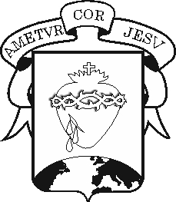
COLEGIO DEL SAGRADO CORAZÓN

PREPARATION WORKSHOP

Subject : English Teacher: Ali Chadid Yaber

Name:_______________________________________________Grade: ________________Date: _____________________________________

- Choose the correct form according to each image and rewrite it.
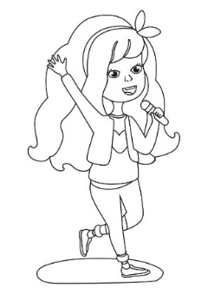

Mary sings/doesn´t sing a song Marcos helps/doesn´t help animals

______________________________ _______________________________

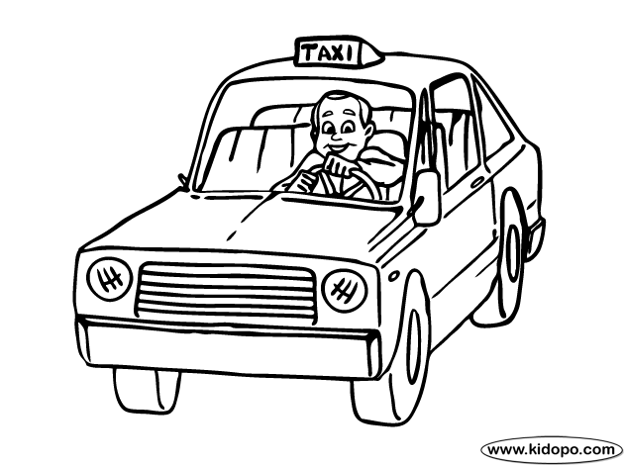

She teaches/doesn´t teach children He plays/doesn´t play basketball

_______________________________ ______________________________

- Look at the images and describe them. Use the following words:

(loves / he / his mother). (The door /doesn´t/ close / Mary).
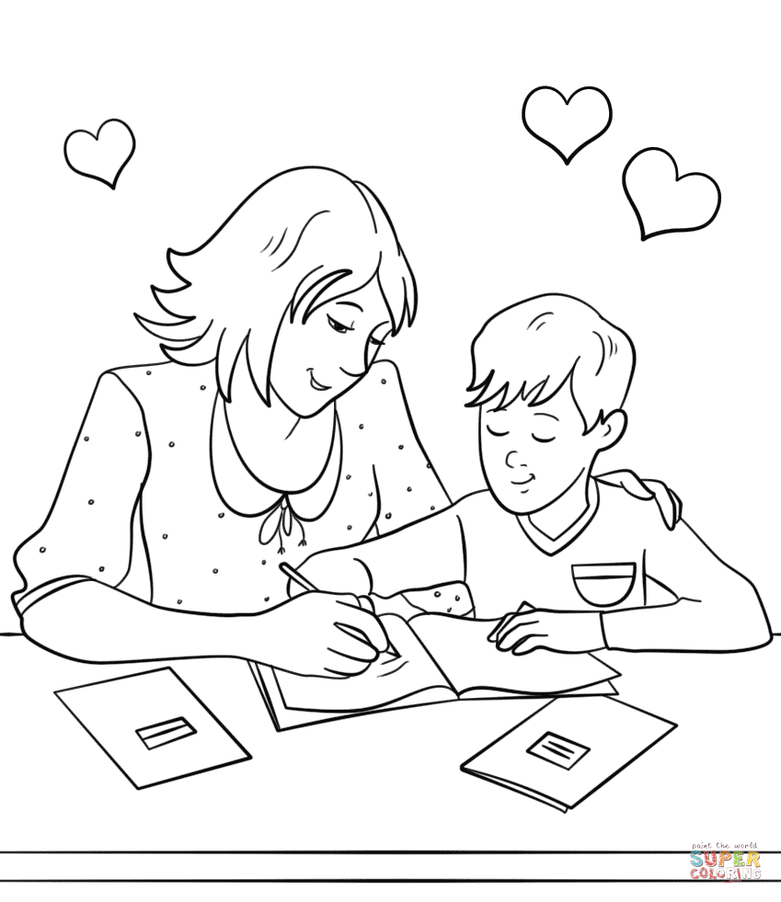
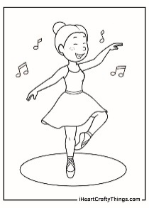

________________________________ ____________________________
- Read and unscramble

- Yina/play guitar/?/does ____________________________________

- Does/dance/?/Paul/where________________________________

- She/does/jump a lot/? ________________________________________

- He/does/sleep/? ____________________________________

- Relate the four seasons with their corresponding weather.
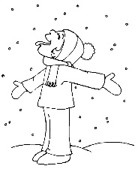
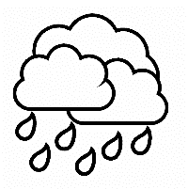

Hows the weather in the summer? It´s____________________
Hows the weather in the spring? It´s ______________________
Hows the weather in the fall? It´s ______________________
Hows the weather in the winter It´s ______________________

- Read the following text and answer whether the statements are true or false:

John is a boy who likes to wear a cap and a scarf. He lives in Australia and love building sandcastles on the beach with his friend Emily during the summer. In January, John usually visits his uncle in Sydney, a very warm city, so he wears shorts and sunglasses.

John likes to wear green shoes ( )
He lives in Brasil ( )
John visit his grandfather ( )
Sydney is a very warm city ( )
John doesn´t love building sandcastles in winter ( )

