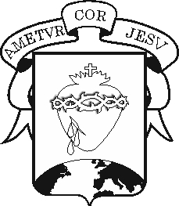
COLEGIO DEL SAGRADO CORAZÓN

WORKSHOP

Subject : English Teacher: Ali Chadid Yaber

Name:_______________________________________________Grade: ________________Date: _____________________________________

- Choose the correct form according to each image.

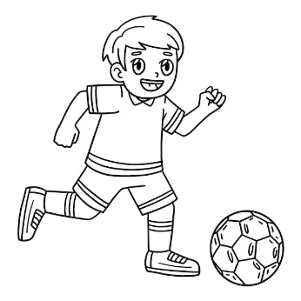
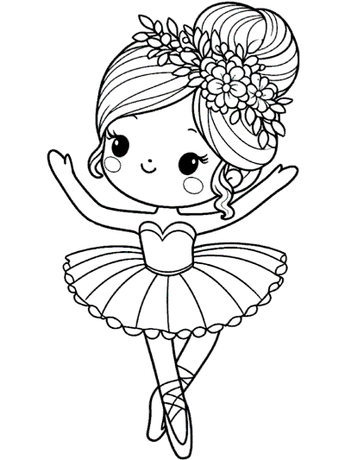

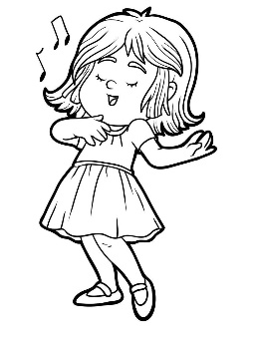
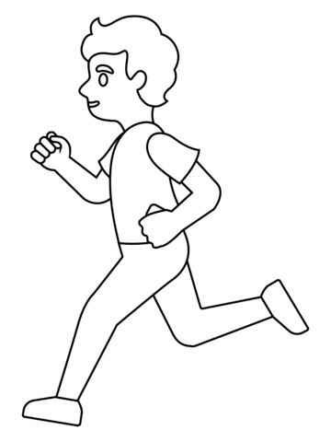
She dances /doesn´t dance a song He writes /doesn´t write a book

Yina cooks /doesn´t cook dinner Marcos runs /doesn´t run fast

- Read and unscramble

- My mom/does/sing/? ________________________________________

- He/does/sleep/? ____________________________________________

- Does/dance/?/Marcos/where__________________________________

- Martha/walk/?/does _________________________________________

- Rewrite using a contraction
(she´s – He´s – Doesn´t)

- She is an engineer ________ an engineer

- He is a taxi driver _______ a taxi driver

- Mary does not sing= Mary _______________ sing

- Paul does not cry a lot= Paul _____________ cry a lot

