Lesson:
The lungs

The lungs are the center of the respiratory (breathing) system.
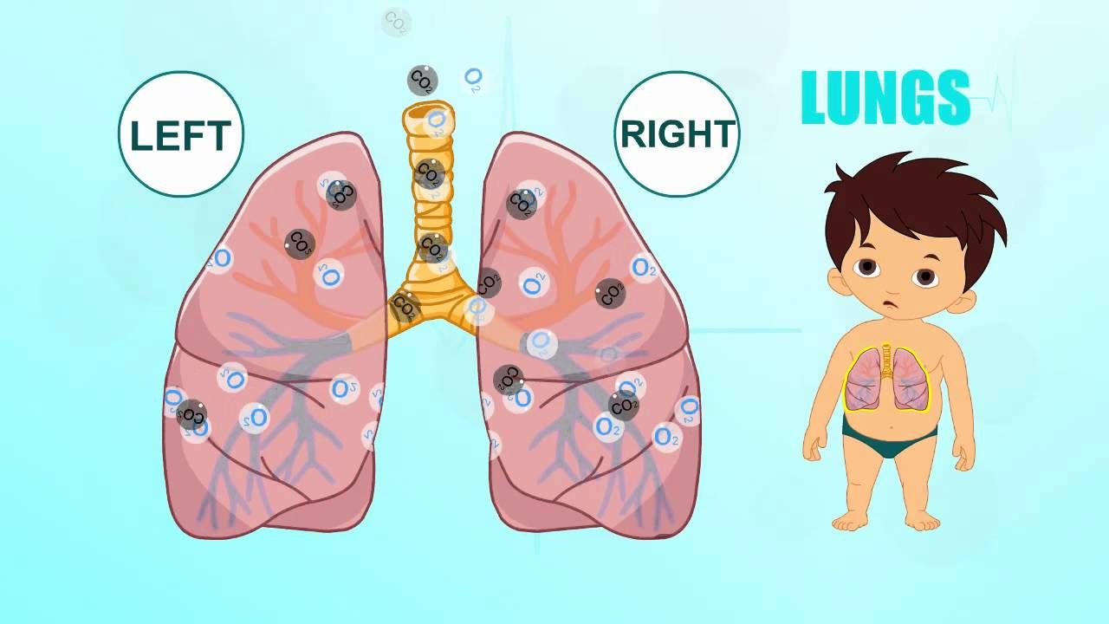
The lungs are the organs that allow us to breath, and their most important function of the lungs is to take oxygen from the environment and transfer it to the bloodstream
The lungs are located in the chest, behind the rib cage, this bony cage helps to protect the lungs and other vital organs of our body.
We need to take care of our lungs, exercising is a good way to do it, because it makes us to breath faster and need more oxygen.

