September 6th, 2021
Lesson
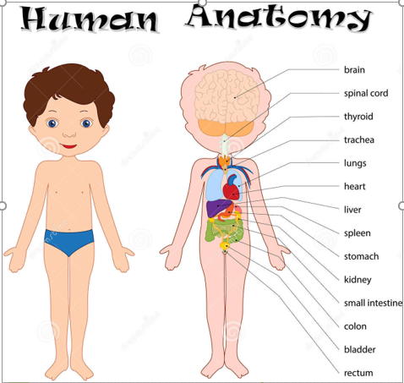
The human body
The human body is made up of many parts.
Vital Organs:
Vital organs are the parts of our body that we need to stay alive.
Our vital organs are:
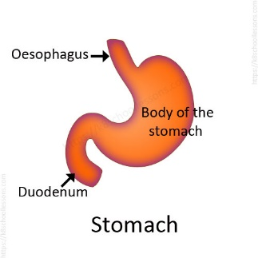
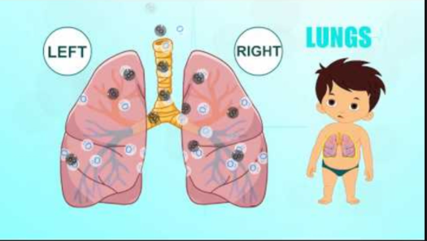
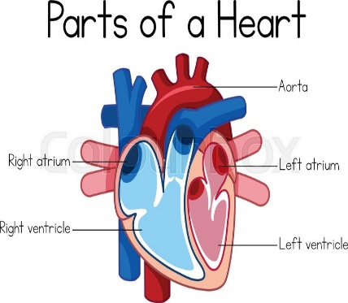
The heart The lungs The stomach

