September 27th, 2021
Lesson
The Muscles
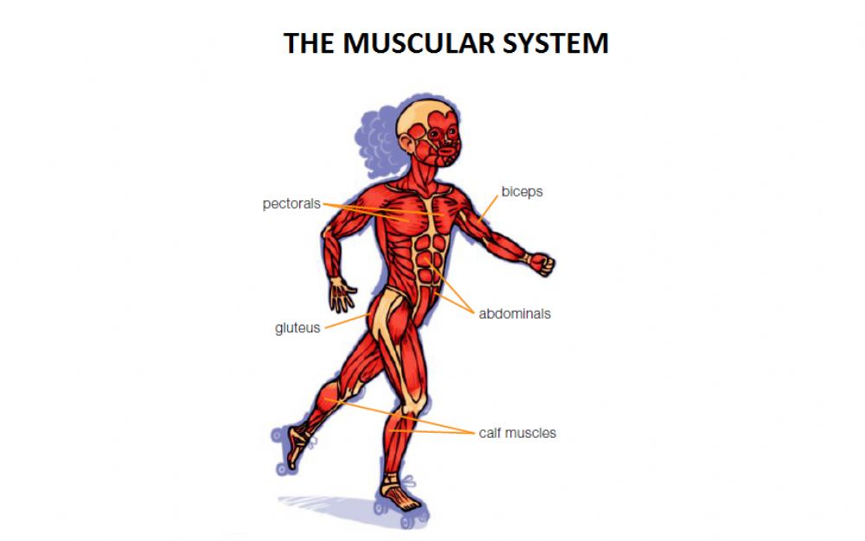
A muscle is an elastic tissue that can contract and expand, or shorten and lengthen. Muscles allow us to move in different ways.
Some muscles are voluntary, which means we can move them when we went to.
For example: Our arms and hands allow us to write.
Other muscles are involuntary, which means they move on their own without our control.
For example: The esophagus muscles push food to our stomach and the heart beats by itself.
To have healthy muscles, you need to exercise regularly and eat well.

