**Taller de repaso de Science del I Período**

1. **Color the living things and circle the non-living things.**

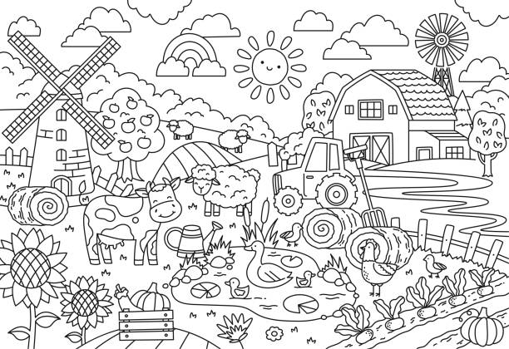

1. **Complete the parts of the plant.**

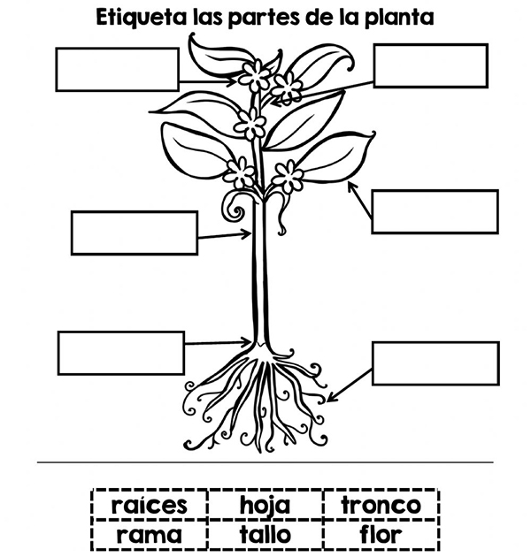

1. **Draw an example of vertebrates animal and invertebrate.**

Invertebrate animal

Vertebrate animal

1. Match

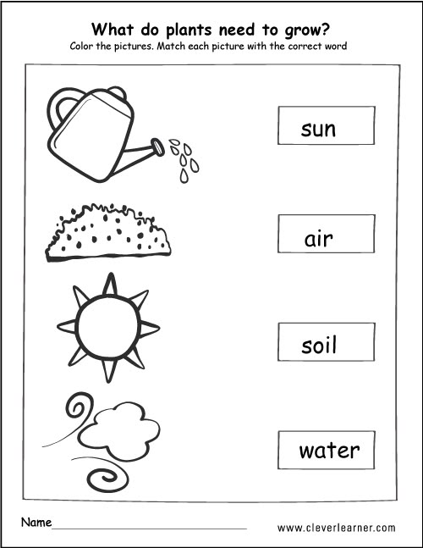

1. Complete

