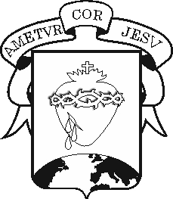

**COLEGIO DEL SAGRADO CORAZÓN**

**FINAL EXAM – FOURTH TERM**

**Subject : English Teacher: Ali Chadid Yaber**

**TOPICS AND STUDY RESOURCES SECOND GRADE**

|  |  |
| --- | --- |
| **TOPICS** | **STUDY RESOURCES** |
| What time do you. (Weekly routine) | https://wordwall.net/play/75734/357/326 |
| Doesn't/Don't | https://wordwall.net/play/80611/084/415 |
| "Do" and "Does" for questions | <https://wordwall.net/play/72578/035/741>  <https://wordwall.net/play/80609/580/360> |
| Seasons and weather | <https://wordwall.net/play/73997/329/706>  <https://wordwall.net/play/72669/935/266>  https://wordwall.net/play/72788/140/190 |
| What do you wear | https://wordwall.net/play/80609/945/322 |
| There is, there are. (Affirmative/Negative) | <https://wordwall.net/play/66222/101/433>  <https://wordwall.net/play/66223/226/650>  https://wordwall.net/play/66289/315/918 |
| Ordinal numbers | <https://wordwall.net/play/79907/885/532>  <https://wordwall.net/play/79907/155/627>  https://wordwall.net/play/80601/127/832 |

Además de estos recursos digitales de estudio, también están disponibles las actividades realizadas en los libros y el cuaderno de inglés. También es importante repasar los exámenes finales del segundo y tercer periodo, ya que saldrán algunos puntos de ellos.