**TOPICS FOR THE FINAL EXAM AND TEST PREPARATION**

* School supplies – Unit 1
* <https://wordwall.net/es/resource/12243014/school-supplies>
* Prepositions (on, in, under) – Unit 3
* <https://www.liveworksheets.com/es/worksheet/en/english-second-language-esl/180790#google_vignette>
* Aquatic animals – unit 5
* <https://www.liveworksheets.com/worksheet/en/english-second-language-esl/385491>
* Like and don`t like – Unit 8
* <https://wordwall.net/es/resource/3575703/i-like-i-dont-like>
* Clothes : Unit 6
* <https://www.liveworksheets.com/worksheet/en/english-second-language-esl/44881>
* Body parts Unit 9
* https://wordwall.net/es/resource/19997504/english/prek-parts-of-the-body
* Adjectives – Unit 9 :

<https://www.liveworksheets.com/worksheet/en/english-second-language-esl/380544#google_vignette>

* Grammar (I `m - I`m not , he is / he isn`t, She is / She isn`t , They are, they aren`t )

<https://wordwall.net/resource/62561780/verb-to-be-negative>

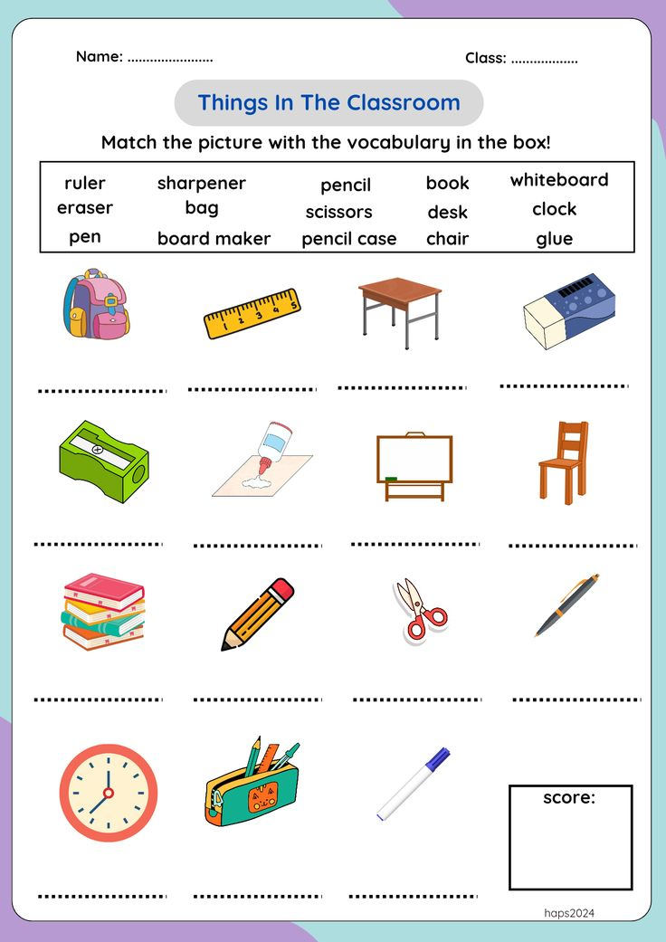

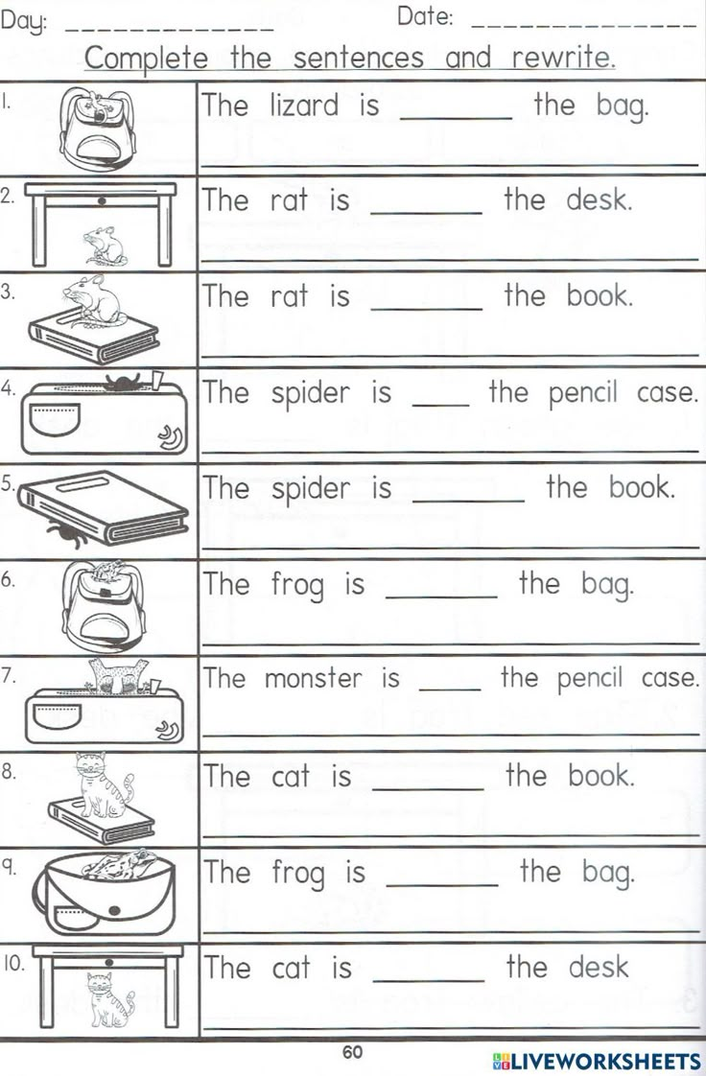

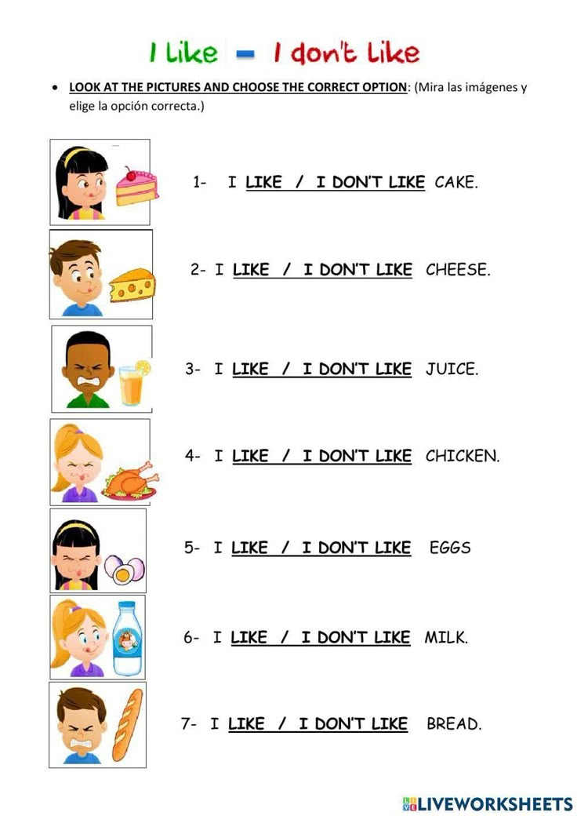V