Activity in class March 3th
Home sweet home

Draw a line to match each habitat to the animals that live there

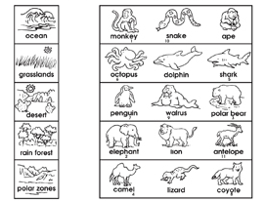

Use the numbered letters above to complete the animal facts.

The world´s largest animal is the __ __ __ __ __ __ __ __ __
3 4 7 1 9 2 5 4 1

One of the world´s slowest animals is the __ __ __ __ __
10 4 8 11 2

One of the world´s fastest animals is the __ __ __ __ __ __ __
6 2 1 1 11 5 2

Activity in class march 5th
Bears live in the forest

Monkeys | 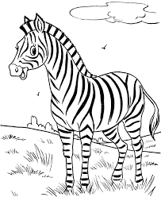  Zebras | 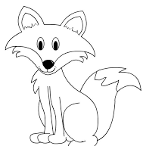  Foxes
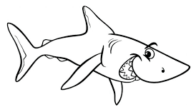  Sharks | Snakes | 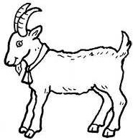  Goats
________________ live in __________________
________________ live in __________________
________________ live in __________________
________________ live in __________________
________________ live in __________________
________________ live in __________________
________________ live in __________________

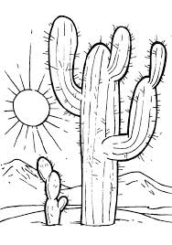  The desert | 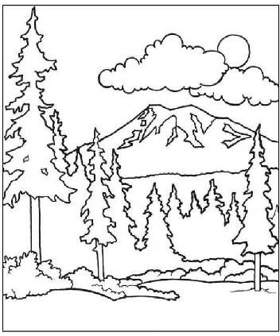  The forest | 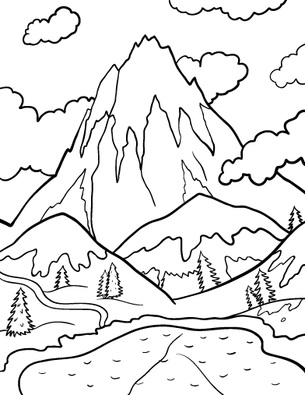  The mountains
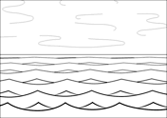  The sea | 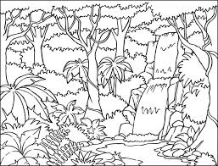  The jungle | 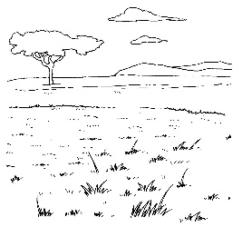  The plains

