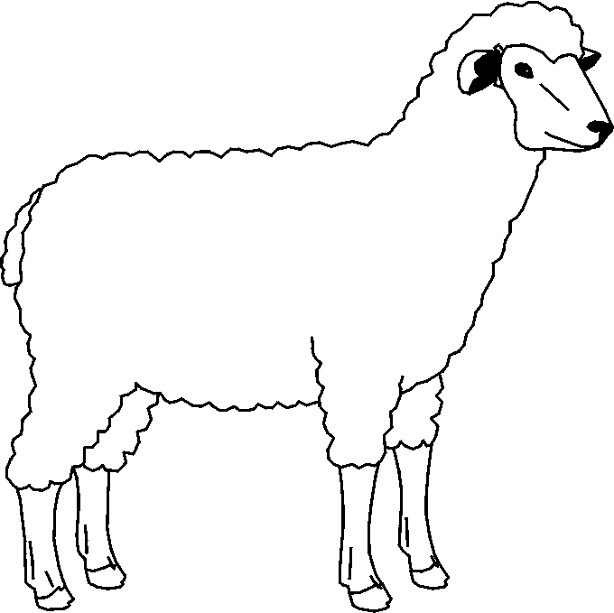 **Activity: Write bipeda l or quadruped. Color.**



 