

***ENGLISH WORKSHEET – FINAL ASSESSMENT***

***THIRD TERM – MISS ADRIANA FORTICH***

***TOPICS: PAST SIMPLE OF TO BE – THERE WAS/THERE WERE – REGULAR AND IRREGULAR VERBS***

***PAST SIMPLE AFFIRMATIVE AND NEGATIVE FORM***

**Materia: Tutora:**

**COLEGIO DEL SAGRADO CORAZÓN**

1. ***Unscramble the sentences in affirmative, negative or interrogative form in past simple tense.***
2. ***they – play- Did- yesterday -a game-?***

***___________________________________________***

1. ***Did- homework- you finish- your-?***

***___________________________________________***

1. ***yesterday - to the supermarket - Lisa - went -.***

***____________________________________________***

1. ***buy – didn’t - My mother - a dress-.***

***____________________________________________***

1. ***My –saw- a movie- yesterday -brother.***

***____________________________________________***

1. ***Reading comprehension:***

***Read and answer the questions in past tense using:***

***past simple of to be - past simple of action verbs - there was – there were:***

***On the Beach***

***Hi! I´m Tom. Last Sunday my parents and I went to the beach, the sun was shining and the weather was very sunny.***

***We bought some food at the beach, and it was very delicious.***

***We played volleyball at the beach, but we didn’t make sand castles because there were a lot of crabs walking on the sand.***

***There was a woman walking her dog, suddenly the dog jumped over the crabs and barked very loudly, it was very funny and we had a lot of fun!***



1. 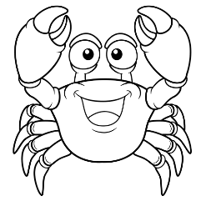***Did Tom and his parents go to the beach?***

***________________________________***

1. ***Did they buy some food at the beach?***

***________________________________***

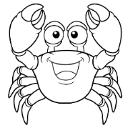

1. 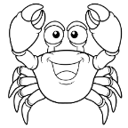***Was it raining?***

***________________________________***

1. ***Did they make sand castles?***

***________________________________***

1. ***Were there crabs at the beach?***

***________________________________***

1. **Write the past of the following verbs:**

|  |  |
| --- | --- |
| **BASE FORM** | **PAST** |
| **GO** |  |
| **BE** |  |
| **SWIM** |  |
| **TAKE** |  |
| **FLY** |  |
| **CATCH** |  |
| **PLAY** |  |
| **ANSWER** |  |
| **SELL** |  |
| **BAKE** |  |
| **FIX** |  |
| **BEHAVE** |  |
| **DECIDE** |  |
| **SEE** |  |
| **AGREE** |  |