PLANT´S UTILITIES
Plants provide us with different utilities to human beings and according to these they have been classified as: food, medicinal, ornamental and industrial.

1.Write what type of plant is it according to its utility

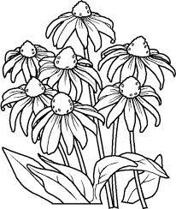

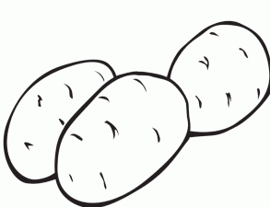

______________________ ______________________ _______________________
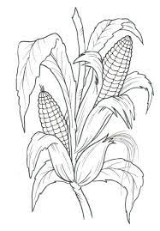

______________________ _______________________ _______________________

2.Classify plants according to their utility

rice eucalyptus orchids aloe vera tomato pine tree cinnamon sunflower

Food | Medicinal | Ornamental | Industrial

