Lesson
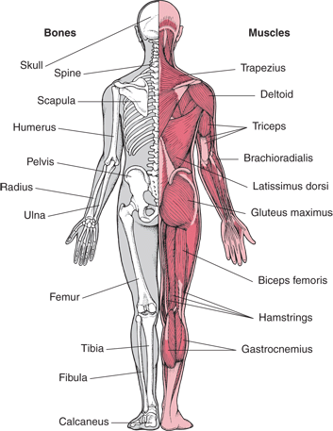
Muscles and bones work together

Movements allow us to do our daily activities. If our muscles and bones do not function correctly, we will have problems moving or problems with vital body functions.

