MATH ACTIVITY

You can draw conclusions from data in a graph:

This picture graph shows student´s favorite sports.
Write how many students chose each sport:
FAVORITE SPORTS
FOOTBALL
SWIMMING | 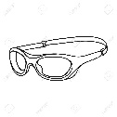
BASKETBALL
ROLLER SKATING

Use the picture graph above to answer the questions:
1.- Which was the least favorite sport? _______________________________________
2.- Which sport did students most vote for? ___________________________________
3.- How many students voted for swimming and roller skating? ___________________
4.- If each student voted only one time, how many students voted in all?
______________________________________

