Lesson

The digestive system
In order to our body to take advantage of the food that we eat, it has to transform it into substances called nutrients.
This process food transformation is called digestion and it is developed by the digestive system.
The stomach is the main organ of the digestive system.
The digestive system: is a long tube thought which the food traveled and is formed by:
1.Mouth: In it begins digestion, teeth cut and grind the food.

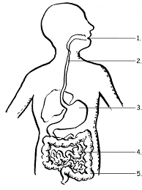

2. Esophagus: It is a tube that carries food from the mouth to the stomach.

3.Stomach: It is a widening of the digestive tract, where food is mixed with gastric juice.

4: Small intestine: It is a small tube and it is 7 meters long, here the digestion ends

5. Large intestine: It is a thicker tube where substances that our body cannot digest accumulate, these substances form the feces.
6: Anus: It is the hole where feces come out.

6.

