Lesson
The Heart
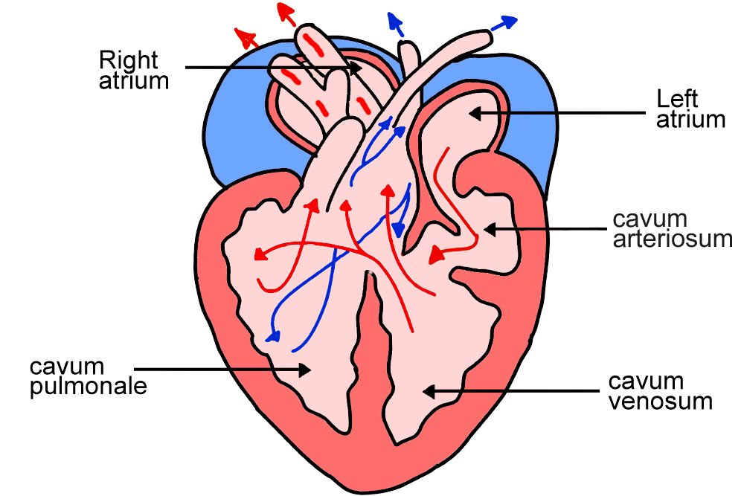
The heart is the muscle that pumps and sends blood rich in oxygen and nutrients to all parts of the body through the blood vessels.

The heart keeps the blood moving in our bodies and it is the main organ of the circulatory system

The heart is the engine of our body and is located to the left of the center of the chest (between the two lungs)
Parts of the heart:
1.Atrium (upper right corner of the heart )
2.Ventricles (Lower right chamber of the heart)
Parts of the heart:
1.Atrium (upper right corner of the heart )
2.Ventricles (Lower right chamber of the heart)

