September 20th, 2021
Lesson
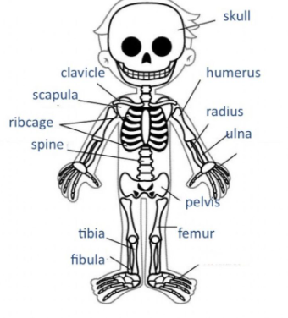
The Skeleton (Bones)
The skeleton supports and gives shape to the body, and together with muscles, it helps us move.
Some bones protect important organs. For example:
- The cranium: protects the brain.
- The rib cage: covers the heart and the lungs.
- Spinal column: protects the spinal cord.

