May 18th 2021
Plant´s utilities
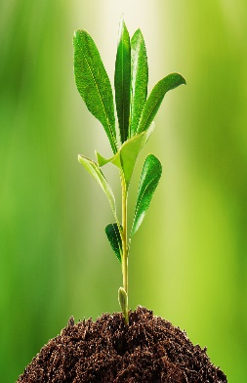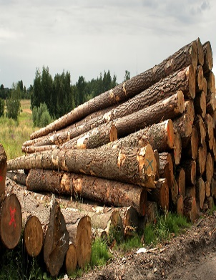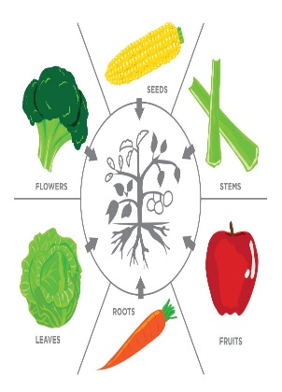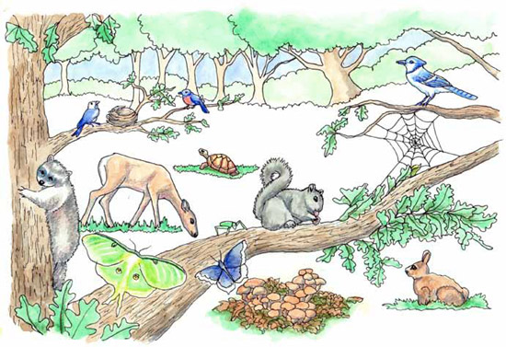
Plants, provide us food, medicine, wood, fuel, and other useful things, besides they provide shelter for many animals, plants produce oxygen and keep the air clean and fresh, maintain the soil and are one important part of the food web.

