October 6th, 2021
Lesson
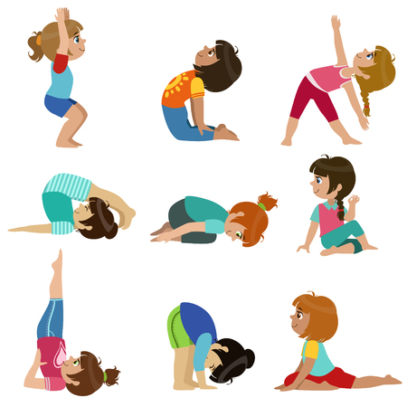
Exercise Plan

We already know that exercise is important for the body.
To make a habitat of exercising consider the following:
- You should spend a maximum of two hours a day sitting down.
- Watching TV. or using the computer are activities that you usually do sitting down.
- If you have a bicycle, use it every day – even for just half an hour.
- Play outside whenever you can. You can jump rope, play soccer or run races.

