October 4th, 2021
Lesson
Taking care of our bodies
(Let´s Exercise)
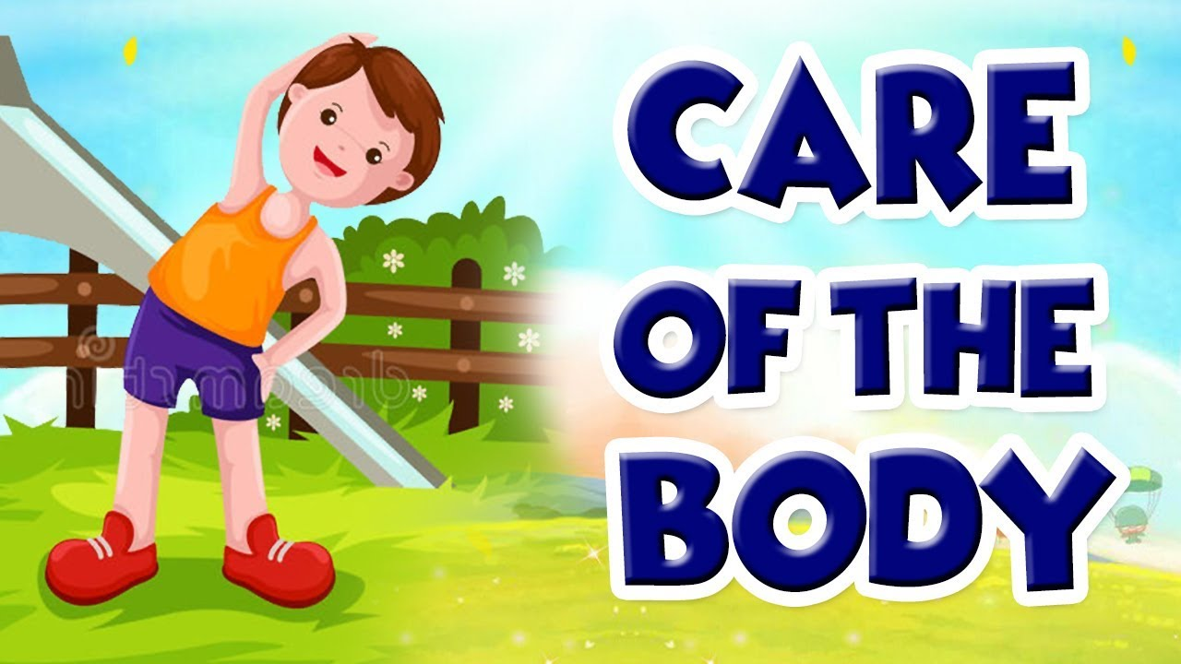
Physical activity, like sports and exercise, are part of a healthy lifestyle and they strengthen bones and muscles.
After exercising, the heart beats faster, which means it is working hard and sending blood quickly to all parts of the body. Every time you run, ride a bike or do other exercise, you are developing muscles that will help you grow and the strong.

