- Locate the names of the organs of the respiratory system
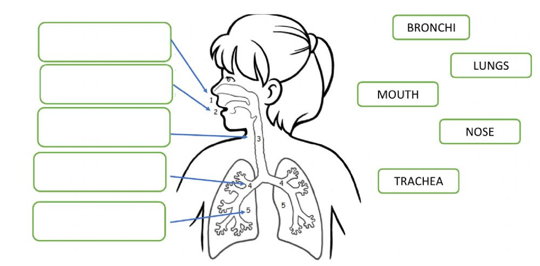
Diaphragmm

- Answer the following questions, uses the word bank
Oxygen involuntary carbon dioxide

- What gas does human being take in when we breathe?
We inhale ____________________

- What gas does human beings eliminate during respiration?
We exhale _______________ _________________.

- Is respiration a voluntary or involuntary movement?
It is an ____________________ movement.

