Vertebrates groups

Write each animal name to the correct animal group.

lion | snake | turtle | elephant | tuna
Monkey | pelican | shark | salmon | lizard
alligator | toad | penguin | frog | ostrich

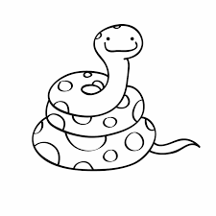
Mammals Reptiles
__________________ _________________

__________________ _________________

__________________ _________________

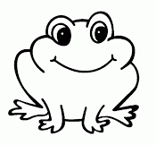
Fish Amphibians

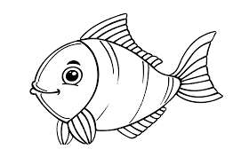
__________________ __________________

__________________ __________________

__________________ __________________

Birds










