Activity August 6

The muscular system

Facial muscles pectorals biceps

Tibialis anterior quadriceps abdominals

What muscles do we use to: Use the word bank

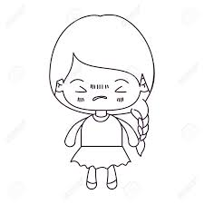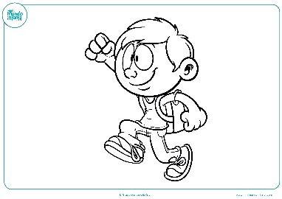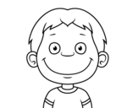

Smile Walk Blink

________________ _______________ _______________

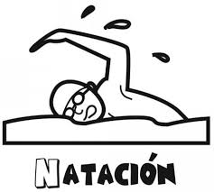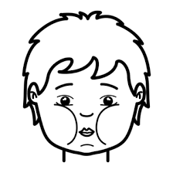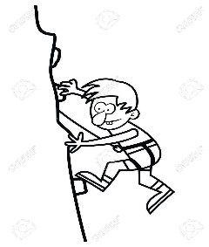

Climb Chew Swim

________________ _______________ ________________

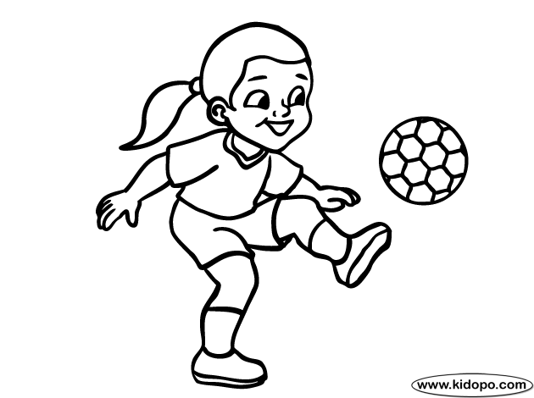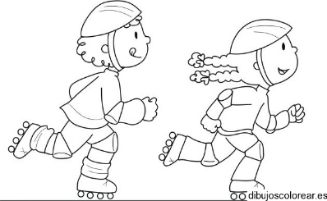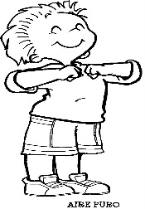

Breathe Roller blading Throw a ball

________________ ________________ _______________