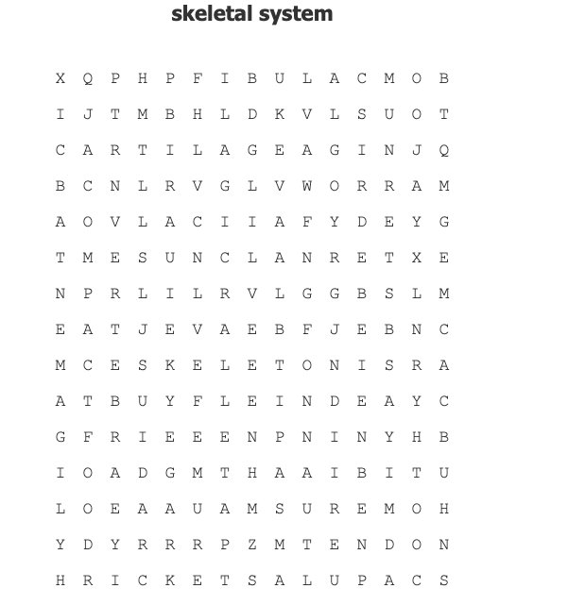
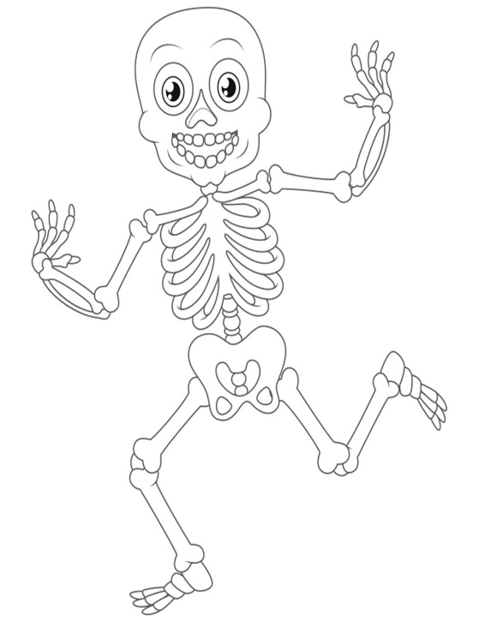

CARTILAGE JOIN RICKETS
CLAVICLE LIGAMENT SCAPULA
COMPACT MANDIBLE SKELETON
CRANIUM MARROW STERNUM
EXTERNAL PATELLA TENDON
FEMUR PELVIS TIBIA
FIBULA PHALANGES ULNA
H0MERUS RADIUS VERTEBRAE

INTERNAL RIB VITAMIN D

